**Personal Protective Equipment for Health and Social Care Staff**

**Guidance Update from the Chief Nurse and Chief Social Work Officer**

**16th April 2020**

**Introduction**

We are now considered to be in a period where sustained transmission of COVID-19 is taking place across the UK. In response to this, current guidance now directs employers of all staff involved in delivery of all aspects of health and social care during the COVID-19 pandemic to apply additional precautions.

The safety of both our staff and the people we support is our key priority and this briefing is designed to ensure that staff have access to the most up to date guidance and are able to relate it to their area of work.

**Incubation and Infectious Period**

The incubation period is from 1 to 14 days (with the average around 5 days) and most people will not be infectious until the onset of symptoms. In most cases, individuals are usually considered infectious while they have symptoms.

**Routes of COVID-19 Transmission**

The transmission of COVID-19 is thought to occur mainly through respiratory droplets generated by coughing and sneezing, and through contact with contaminated surfaces.

**Current Guidance on PPE in Community Health and Social Care Settings**

Comprehensive guidance on the use of PPE in community health and social care can be found on the [Health Protection Scotland](https://www.hps.scot.nhs.uk/a-to-z-of-topics/covid-19/) website. Staff are encouraged to visit the Health Protection Scotland website on a regular basis to ensure that they have the most up to date information.

When determining the type of PPE to be used, staff need to ensure that in advance of providing care, they have access to the necessary information to allow them to assess the type of PPE required. The guidance makes it clear that staff should self assess risk and wear the items of PPE they consider necessary in their work to ensure both their own safety and that of the person they are caring for. Requirements for use of PPE in community health and social care settings are summarised in the table below.

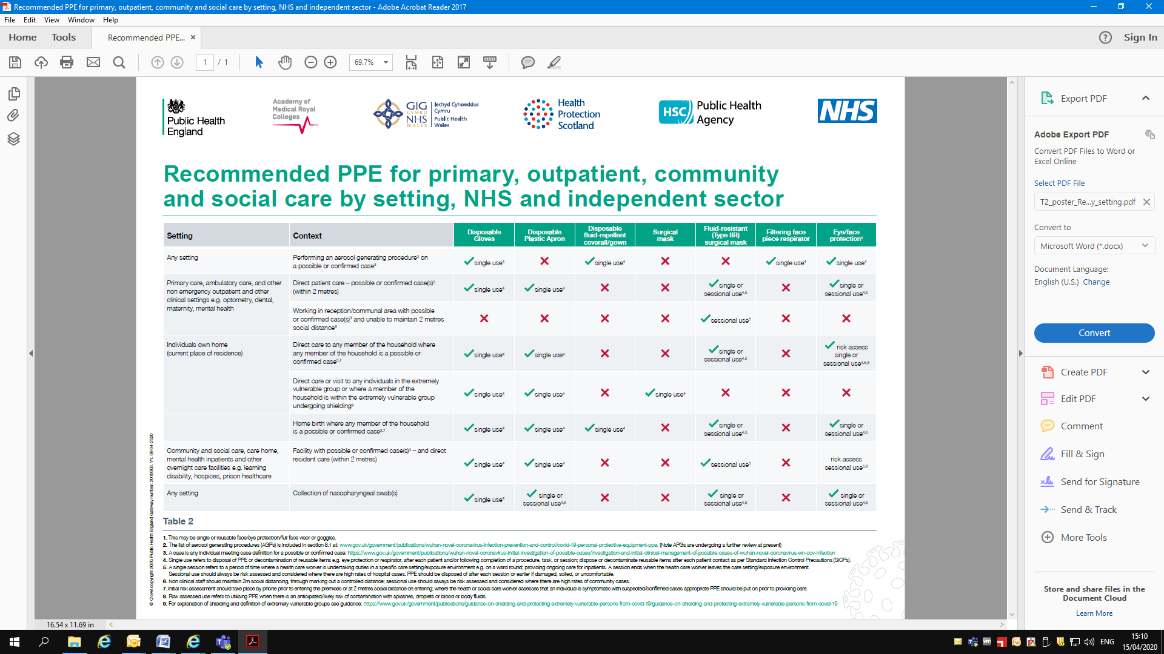

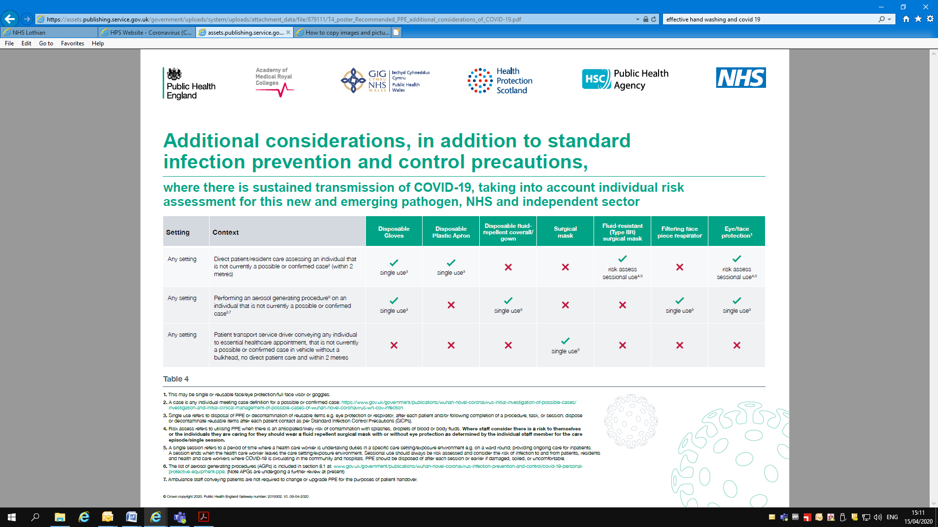

**Staff Not Delivering Direct Personal Care**

People working in a public space, office, room or area where there is no ongoing care activity or where social distancing is possible, do not need to wear PPE. Staff should follow social distancing guidance and good hand hygiene.

Staff who normally undertake home visits should consider whether the visit is essential or could be carried out in another way. Where no alternative is possible, staff should observe social distancing guidance and should self assess PPE requirements.

Staff should check all records and information available to them in advance of any visit. Those checks should be followed up with a telephone call or message to the individual to establish whether anyone in the household has symptoms of CODID-19 or are shielded.

**Staff Delivering Direct Personal Care**

For direct care of people with possible or confirmed cases of COVID-19, plastic aprons, gloves and fluid resistance surgical masks should be used. The need for eye protection should be determined through risk assessment of the type of care being delivered. If undertaking any care with a risk of splash, spray or other contact with any blood or bodily fluids, staff should wear the appropriate face and eye protection.

Health and social care staff can wear a fluid resistant surgical mask along with other appropriate PPE where the person they are visiting or otherwise attending to is neither confirmed nor suspected of having COVID-19, if they consider doing so necessary to their own safety or the safety of person they are caring for following a self assessment.

**Self Assessment of Risk**

* Initial risk assessment starts with checking information, systems and records available
* Staff should phone or message prior to visiting to determine in advance whether social distancing is possible or whether there is anyone in the household with COVID-19 symptoms
* Where the potential risk to staff cannot be established prior to face-to-face assessment or care delivery the recommendation is for staff to have access to and where required wear aprons, fluid resistant surgical masks, eye protection and gloves
* Staff should consider the need for contact and droplet precautions based on the nature of care or task being undertaken. Risk assessment on the use of eye protection, for example, should consider the likelihood of droplet transmission to eyes such as with a coughing patient during care provision.
* For direct care of possible or confirmed cases in facilities such as care homes, mental health inpatient units, learning disability and autism residential units and other overnight care units, plastic aprons, fluid resistant surgical mask, and gloves should be used. Need for eye protection is subject to risk assessment meaning dependent on whether the nature of care and whether the individual symptoms present risk of droplet transmission
* Staff should decide on the basis of self assessment what type of PPE is appropriate to the setting, area and task they are about to undertake

**Step 1 – Wash Your Hands**

See page 9 for guide to washing your hands

**Step 4 - Wash your Hands**

**Step 2- Putting on PPE**

It is essential that staff follow the correct procedures for applying and removing PPE. Put PPE on before entering care area - in the hallway or reception area. It should be on in this order:

**1 - Apron**

**2 - Mask**

**3- Gloves**

Wash your hands with soap and water immediately after all PPE has been removed and dry them with disposable towels. If you cannot wash your hands use an alcohol based hand gel.

* **DO NOT re-enter the care area,** or within 2 metres of the person receiving care.   
  Use alcohol based hand gel when leaving if necessary.

**Do not leave the person’s home wearing any form of PPE (masks. aprons, gloves)** - Wearing gloves or masks out with a service user’s home will increase the risk of cross contamination

* If goggles are assessed as being required they should be applied after the mask
* Keep your hands away from your face and the PPE you are wearing
* Change your gloves if they are heavily contaminated/soiled/torn

**Step 3 - Taking Off PPE**

Remove PPE after leaving care area - in the hallway or reception area and place in a waste bag. It should be removed in an order that minimises cross-contamination.

**1 – Gloves**

**2 - Apron**

**3 - Mask**

|  |  |
| --- | --- |
|  |  |
|  | * Grasp the outside of the glove; peel off and hold removed glove in gloved hand * Slide the fingers of the un-gloved hand under the remaining glove at the wrist; peel the glove off and discard appropriately |
|  |  |

[Click here to: Watch this film on the correct way to put on and take off PPE](https://www.hps.scot.nhs.uk/web-resources-container/covid-19-the-correct-order-for-donning-doffing-and-disposal-of-personal-protective-equipment-ppe-for-healthcare-workers-hcws-in-a-primary-care-setting/)

|  |
| --- |
| * Unfasten or break ties; Pull apron away from the neck and shoulders, touching the inside of the apron only. * Turn the apron inside out, fold or roll into a bundle and discard |
|  |

* Untie or break bottom ties of mask, followed by top ties or elastic and remove by handling the ties only and discard as clinical waste. If you are wearing goggles or a visor they should be removed after the mask

|  |  |
| --- | --- |
|  |  |

**Disposal of PPE**

Dispose of PPE and personal waste (e.g. used tissues, disposable towels and cleaning cloths) securely within disposable bags. When full, the disposable bags should be placed in a second bag and tied.

Waste bags should be stored for 72 hours before being put out for collection in the usual way. They must not be left in a communal building bin and if stored outside they must be in a solid container (e.g. wheelie bin) and away from the public street.

**Sessional Use of PPE**

Aprons and gloves are subject to single use with disposal and hand hygiene after person contact. Fluid resistant surgical masks and eye protection may be used on a sessional basis in certain circumstances.

A single session refers to a period of time where a health and social care worker is undertaking duties in a specific area such as a meal round or a medical round in housing with care. A session ends when the health and social care worker leaves the clinical care setting. Once the PPE has been removed it should be disposed of safely. The duration of a single session will vary depending on the activity being undertaken.

The rationale for recommending sessional use in certain circumstances is to reduce risk of inadvertent indirect transmission, as well as enabling delivery of efficient care.

PPE should not be subject to continued use if damaged, soiled, compromised, uncomfortable – if so a session should be ended. Appropriateness of single versus sessional use is dependent on the nature of the task or activity being undertaken and the local context.

The table below outlines the items of PPE which can be used on a sessional basis.

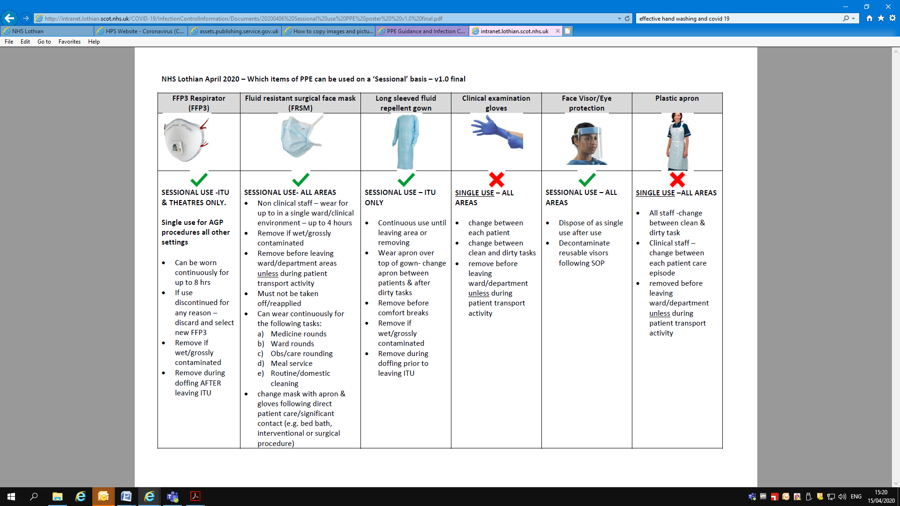

**Visiting a Person Who is Shielded**

Shielding is a measure to protect people, including children, who are at a very high risk of severe illness from COVID-19 because of certain underlying health conditions. People who are to be shielded will have received a letter from the government advising them of the precautions they should take. Health and care workers who provide essential support such as healthcare, personal support with daily needs, or social care should continue to make home visits to vulnerable people who are shielding. However, every effort should be taken to minimise personal interaction between shielded individuals and others to protect them. Managers will be aware of people who are being shielded and who are in receipt of community nursing care and/or social care support.

Staff undertaking direct personal care or visiting a shielded person must wear an apron, gloves and mask as directed by the guidance.

Health and care workers must stay away from shielded individuals if they have any of the symptoms of Coronavirus (COVID-19) or other illness.

**Frequent Hand Washing**

Frequent hand washing with soap and water remains one of the most effective ways to stop the spread of Coronavirus (COVID-19).

* Wash hands frequently with soap and water in accordance with the guidance
* Use alcohol-based hand rub where available if no access to soap and water
* Avoid touching eyes, nose and mouth with unwashed hands
* Avoid direct contact with people who have a respiratory illness wherever possible
* Avoid using personal items (e.g. mobile phone) of people that have a respiratory illness wherever possible
* Cover nose and mouth with a disposable tissue when sneezing, coughing, wiping and blowing the nose. Dispose of all used tissues promptly into a waste bin. If you don’t have any tissues available, cough and sneeze into the crook of the elbow. Wash or use alcohol-based hand rub to clean hands at the first opportunity.

The table below provides a reminder of good hand washing practice:



**PPE Frequently Asked Questions**

1. **What information should I be gathering in advance of completing an essential home visit**

For social care staff SWIFT/AIS must be checked. Warning /hazard indicators have been updated to identify if a client is shielding or where they have had previous contact with social policy and known or suspected to have symptoms of COVID-19. Health staff should check the appropriate clinical system.

Contact the service user via telephone or text – to establish if they or a member of the household are following household isolation or shielding advice. If they are following this advice and a visit is deemed essential, then a full risk assessment should be undertaken with your manager to decide the best course of action. This will include what PPE requires to be utilised.

If you are unclear on what to do in advance of a home visit please discuss with your line manager/duty manager.

1. **The guidance states in certain situations I should risk assess what types of equipment to use e.g. masks and eye/face protection. What does this mean?**

Where staff are providing care to service users who are known to be possible or confirmed COVID-19 cases, PPE recommendations are specified. Attempts should be made to ascertain whether the service user is a possible or confirmed case of COVID-19 before service provision.

Initial risk assessment where possible should take place by phone or other remote method prior to entering the premises or at 2 metres social distance on entering.

Where it is assessed that an individual is symptomatic, appropriate PPE should be put on prior to providing care.

Where the potential risk to staff cannot be established prior to face-to-face assessment or delivery of care is within 2 metres, the recommendation is for staff to have access to and where required wear aprons, fluid resistant surgical masks, eye protection and gloves.

Risk assessment on the use of eye protection, for example, should consider the likelihood of droplet transmission to eyes, such as with a coughing patient during care provision.

For direct care of possible or confirmed cases in facilities such as care homes, mental health inpatient units, learning disability and autism residential units and other overnight care units, plastic aprons, fluid resistant surgical masks and gloves should be used. Need for eye protection is subject to risk assessment meaning dependent on whether the nature of care and whether the individual symptoms present risk of droplet transmission.

1. **I often have to visit service users that I know very little about; would it not be safer to wear masks to all visits?**

An initial risk assessment should be completed prior to any visit e.g. requesting information on symptoms, is anyone following household self isolating or shielding? Is this an essential visit? Can I provide the support via social distancing? If a visit is deemed essential, then you must consider what PPE is required to keep yourself safe in line with the guidance.

1. **If our service users are asking us to wear masks to help them feel safer, can we do this?**

In these circumstances, PPE guidance should be explained to the service user. Where social distancing is possible you should provide reassurance to the service user. Where the service user cannot be reassured and the visit could be compromised, then you should wear a mask.

1. **I do not deliver personal care as part of my role. Do I need to wear PPE?**

If you can maintain appropriate social distancing then you do not need to wear a mask. PPE is only required if the service user or a member of the household are self isolating or are shielded. If they are and the visit is essential, then a full risk assessment should be undertaken with your manager to decide the best course of action. This will include what PPE requires to be used. Staff should decide on the basis of self assessment what type of PPE is appropriate to the setting, area and task they are about to undertake.

1. **I don’t have PPE and think I need it. What should I do?**

Staff should check current guidance and assess whether they think PPE is required for the setting, area or task. If you are still unclear you should discuss your situation with your line manager.

1. **Can staff choose to wear masks, gloves and aprons when conducting home visits to houses where there is no-one shielding or self-isolating?**

Staff should decide on the basis of self assessment what type of PPE is appropriate to the setting, area and task they are about to undertake